Web Design and Development
4COSC011C.3

Report

Student Name: Ahamed Aathif
Student ID: W2053156 / 20222350

Group Number: 22 Student Role: 4

Link(s) to WebSite
URL:

Table of Contents
1. Introduction 3
2. Technical Discussion 5
1. Gallery Page 5
2. SiteMap Page 8
4. Editor Page 13
5. Nav Bar 16
3. Webpage Validation Statement 20
4. Janet 21
Appendices 21
Appendix A: Code 21
• Gallery Page HTML 21
• SiteMap Page HTML 27
• SiteMap Page CSS 30
• Content Page HTML 34
• Content Page CSS 37
• Page Editor Page HTML 41
• Page Editor Page CSS 43
• Gallery Page 46
• SiteMap Page 47
• Content Page 48
• Page Editor 49
• SiteMap Page 50
• Gallery Page 51
• Content Page 51
Appendix D: Individual Statement 52
Appendix E: Task Completion Checklist 53

1. Introduction
Section guidelines:
- List of the team members, allocation of tasks (student 1 to 4), and topic of the website.
Student Name | Student Role
Huzrin Hussain | Student 1
Thanzeel Bin Kaiff | Student 2
Saad Mazhar | Student 3
Ahamed Aathif | Student 4
Website Topic – Zero Hunger
Website Name – The Hunger Gap

- Include the summary table of your contributions to the group meetings.

Group Coursework Meetings (minimum 5 meetings, e.g., one per week)
1 | Date & Time: | 03/03/2024 -12.30 p.m.
1 | Objective: | Coursework planning & Student role assigning
1 | Attended: | All Students attended
1 | Your Contribution: | Took the Student role 4.  Suggested Zero Hunger as our website topic
2 | Date & Time: | 13/03/2024-12.30 p.m.
2 | Objective: | To discuss about the website logo and additional content webpage.
2 | Attended: | All Students attended
2 | Your Contribution: | Provided feedback on selected logo and suggested a theme color for the website.
3 | Date & Time: | 27/03/2024 – 12.30 p.m.
3 | Objective: | To discuss about the presentation page, main (home) page, shop, quiz, site map , gallery and about us page.
3 | Attended: | All Students attended
3 | Your Contribution: | provided the required HTML, External CSS and External  JavaScript codes for the Navigation Bar as per the coursework specifications.
4 | Date & Time: | 30/03/2024 – 7.30 p.m. (Online)
4 | Objective: | Progress Meeting
4 | Attended: | All Students attended
4 | Your Contribution: | I provided feedbacks and opinions on the layout, presentation and codes.
5 | Date & Time: | 03/04/2024 –. 12.30 p.m.
5 | Objective: | Finalizing
5 | Attended: | All Students attended
5 | Your Contribution: | Finalized the html, CSS, java scripts and validated without any errors

2. Technical Discussion

Student 4 Tasks:
Common Choices

- The project follows standard document guidelines by using HTML5 as the document type, ensuring compatibility and modern features. English language is consistently assigned to all webpages using the "lang" attribute, aiding search engines and accessibility tools. UTF-8 encoding is specified in the "meta" tag to support various languages and special characters. Furthermore, the “Nav.css and Footer.css” stylesheets are included to all the pages css, ensuring a consistent and cohesive design for the navigation bar and footer elements.

- In accordance with the coursework specifications, it is mandatory for every web page that is created to include a Page Editor page at the end of the page. This requirement is met by implementing the footer element this creates the footer section at the bottom of the webpage, typically used for additional information and links related to the entire page. An element this represents an anchor link that points to the "Editor.html" page. Users can click on the link to navigate to the specified "Page Editor" page

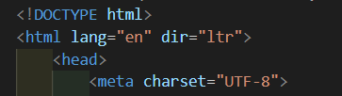

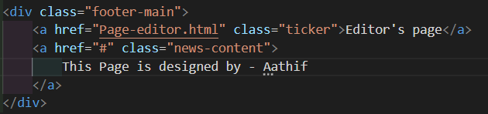

Gallery Page

The provided HTML document showcases a Gallery page, featuring a blend of HTML structure, CSS styling, and potential for JavaScript functionality enhancements. Here's a detailed breakdown:

The document leverages semantic HTML to enhance accessibility and SEO. The <header> section contains navigation links, showcasing a well-structured approach to site navigation. The use of <nav> and <ul> elements for the navigation bar promotes ease of navigation for users, allowing for a seamless experience across different sections of the site. The main content is housed within a <section class="gallery-main">, where each piece of content is wrapped in <div class="card"> containers. This structure not only organizes the gallery efficiently but also sets the stage for enhanced interactivity and styling. Images within the gallery are given descriptive alt attributes, emphasizing the site's accessibility and user-friendly nature.

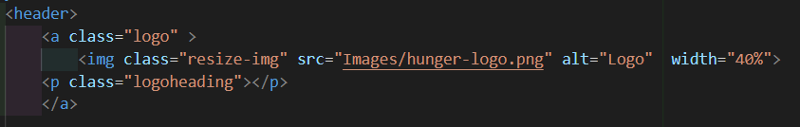

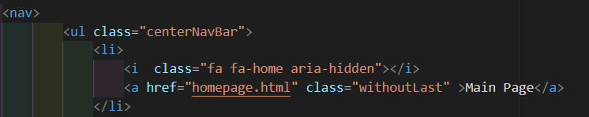

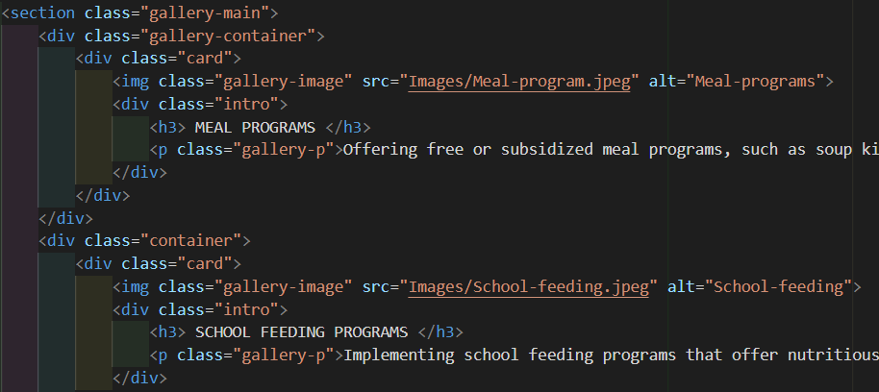

The CSS, although briefly outlined, indicates a focus on creating a visually appealing gallery. The styling efforts aim to present the gallery content in a neat and engaging manner, with .card elements designed to stand out through the use of box shadows, creating depth. The .gallery-image class ensures that images are displayed prominently within each card, with specific dimensions for consistency. The .intro class applies a stylistic overlay effect on hover, which not only adds to the visual appeal but also provides a dynamic user interaction with the gallery items. The use of fonts such as Arial and Poppins suggests a priority for readability and aesthetic presentation.

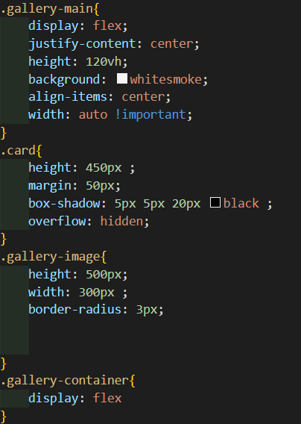

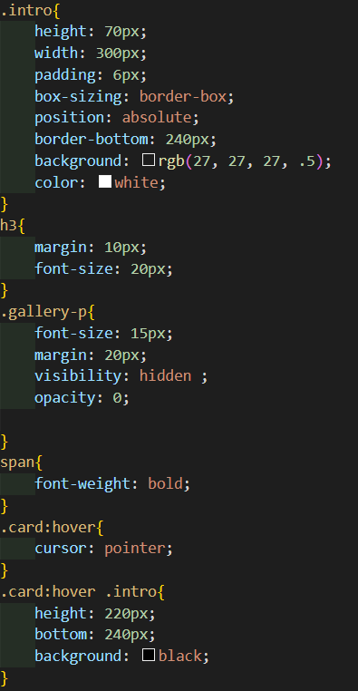

SiteMap Page

The provided HTML document, along with its CSS styling, represents a comprehensive SiteMap page designed to guide users through the website's structure effectively. This combination of HTML and CSS, although not directly incorporating JavaScript functionality in the snippet, lays down a robust foundation for potential interactive enhancements. Here’s a detailed analysis based on the structure, styling, and potential for JavaScript functionality:

The HTML structure demonstrates a clear and accessible layout, beginning with a <header> that includes a navigation bar, thereby offering intuitive site-wide access. Each navigation item is carefully marked with FontAwesome icons, enhancing visual appeal and user understanding. The <body> of the document focuses on the SiteMap itself, encapsulated within a <div> tagged with an id of sitemap-svg, showcasing an SVG representation of the website's layout. This SVG map provides a visual guide to the site's structure, with links to various pages like the homepage, gallery, shop, and more, making the website's architecture both comprehensible and navigable.
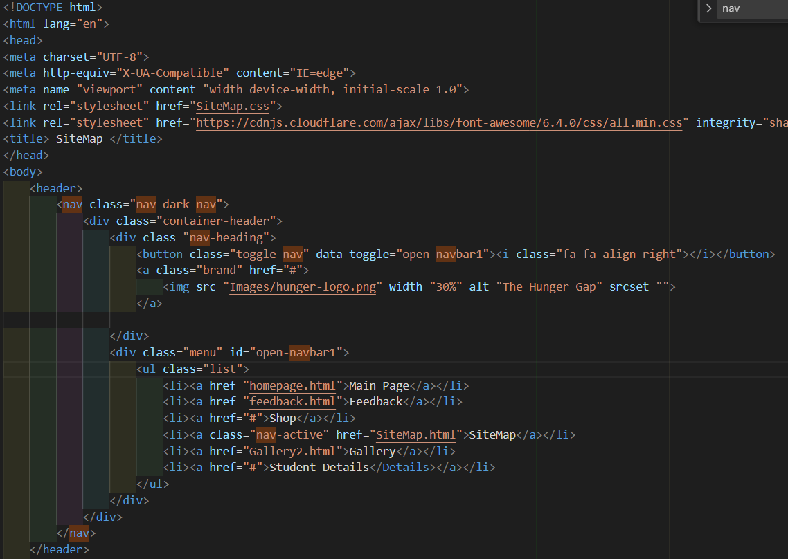

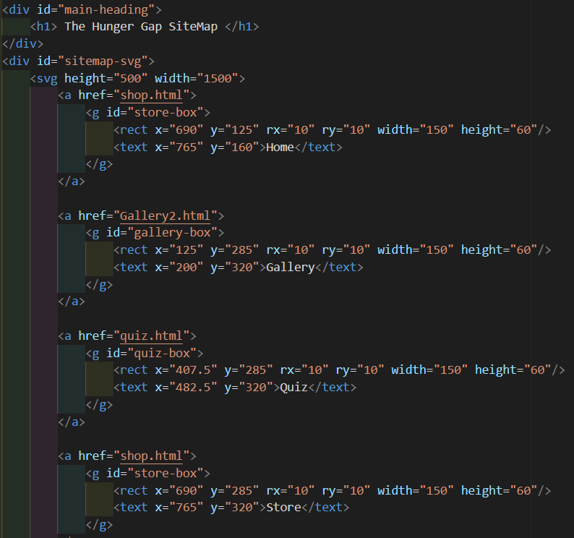

The CSS styling details a visually appealing design language that is both functional and aesthetically pleasing. The background settings ensure the content is easily readable against a contrasting backdrop, with the SiteMap's SVG lines and rectangles styled for visibility and interactivity. Hover effects on the SVG elements invite user interaction, while the consistent use of the 'Poppins' font family across headings and text ensures readability. The overall design is clean and modern, with careful attention to details such as the header's background color and the styling of navigation links to maintain a cohesive look and feel.

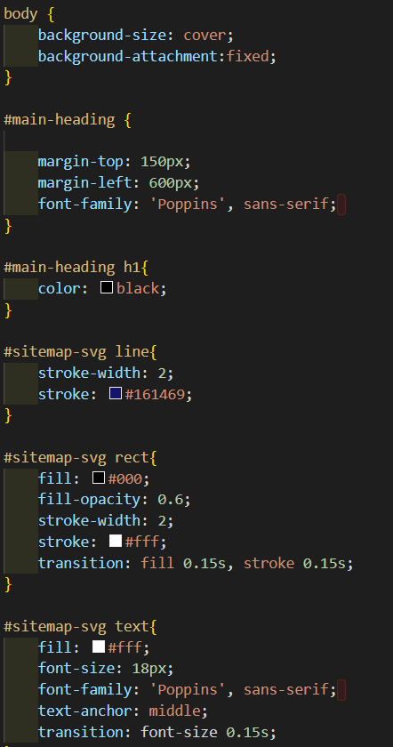
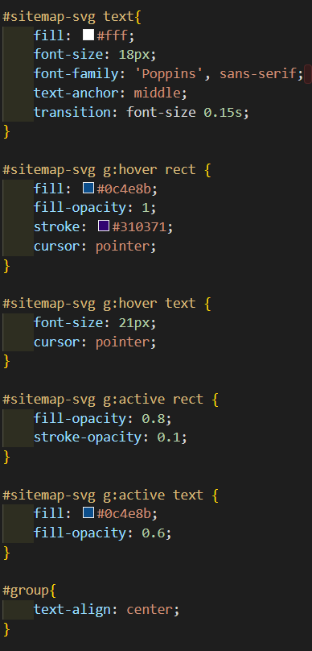

- Content Page

The provided HTML document, styled with CSS, outlines a content-rich page aimed at discussing sustainable solutions to hunger. It skillfully integrates typography, layout design, and navigational elements to present an engaging and informative user experience. Here's a detailed analysis based on the structure and styling:

The document is well-structured, starting with a `<head>` section that includes essential metadata, a link to a CSS file for styling, and Google Fonts for enhanced typography. The `<body>` comprises a `<header>` featuring a logo and navigation bar, facilitating easy site navigation. The core content is organized into several `<div>` elements, each representing different topics related to sustainable solutions for hunger, such as "Agricultural Innovation" and "Food Distribution Systems." This organization ensures the content is accessible and logically arranged, with each section linked for easy access through navigation links.

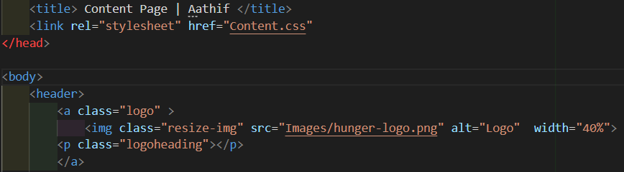

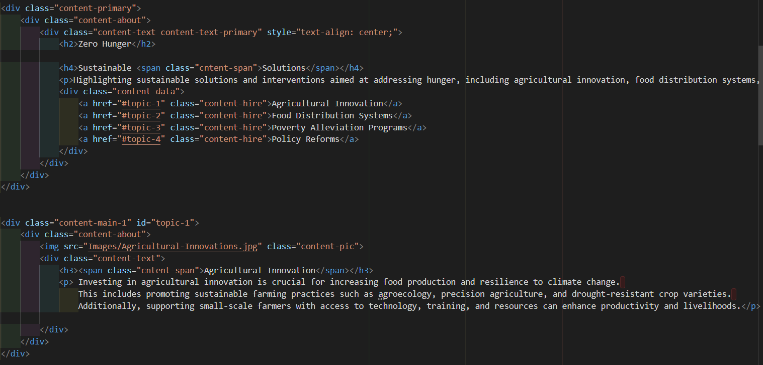

The CSS styling, linked externally, establishes a visually appealing and user-friendly page design. The use of Google Fonts like 'Josefin Sans' and 'Poppins' adds a modern and readable typography layer to the content. Background colors and padding are strategically applied to differentiate between sections, enhancing readability and user engagement. The `.content-hire` buttons are styled to stand out, encouraging user interaction. The overall layout is responsive, ensuring the content is accessible across various devices, which is critical for reaching a broader audience.

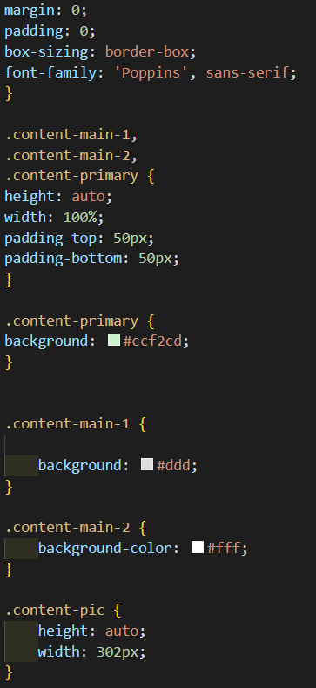

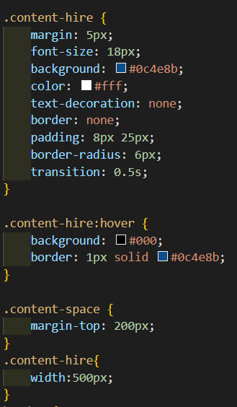

The navigation bar at the top, styled for clarity and ease of use, allows users to effortlessly move between different sections of the site. The inclusion of accessible and descriptive links in the navigation bar (`<a href="homepage.html" class="withoutLast" >Main Page</a>`) improves the site's usability. Furthermore, the `alt` text on images (`<img class="resize-img" src="Images/hunger-logo.png" alt="Logo">`) enhances the page's accessibility, ensuring all users, including those using screen readers, can navigate and understand the content effectively.
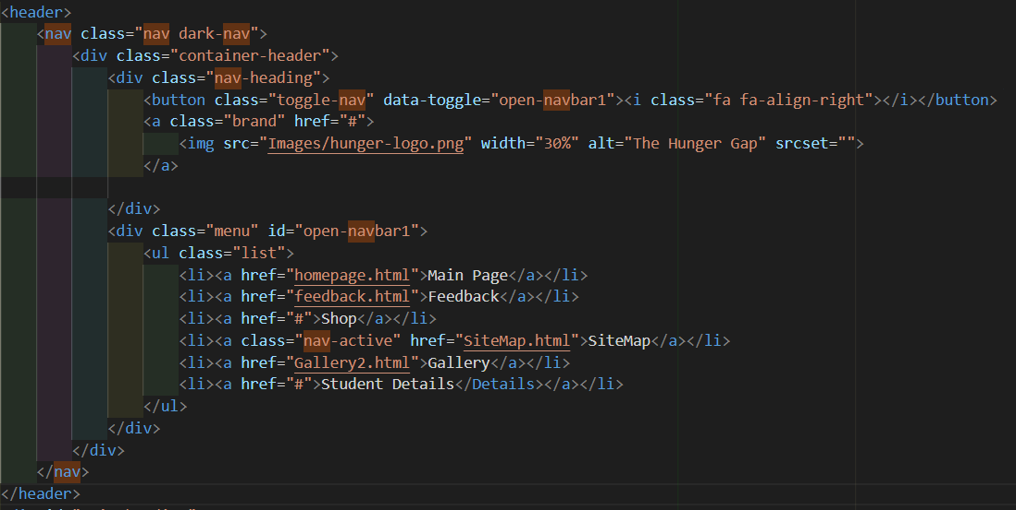

This HTML document, with its CSS styling, provides a solid framework for a content page focused on addressing hunger through sustainable solutions. The careful structure and styling underscore the importance of readability, accessibility, and user engagement in web design. By integrating modern typography, responsive layout, and clear navigation, the page effectively communicates its message and encourages user interaction, serving as an exemplary model for content-centric web pages.

Editor Page

HTML Structure

This HTML document, enriched with CSS styling, presents a page editor profile for "Ahamed Aathif," highlighting his role and contributions to a project. It employs modern web development practices to create an engaging user experience focused on content clarity and visual appeal. Here's an analysis based on the provided structure and styling:

The document uses semantic HTML5 to ensure proper content structuring and accessibility. The `<head>` section includes metadata, external stylesheet links for fonts and custom styles, and a title that provides context for the page's purpose. The `<body>` comprises a container that encapsulates a card representing the page editor's profile, featuring an image, personal information, and a list of tasks or contributions made by the editor. Each task is linked to further details, offering a straightforward yet comprehensive overview of the editor's work and areas of responsibility.

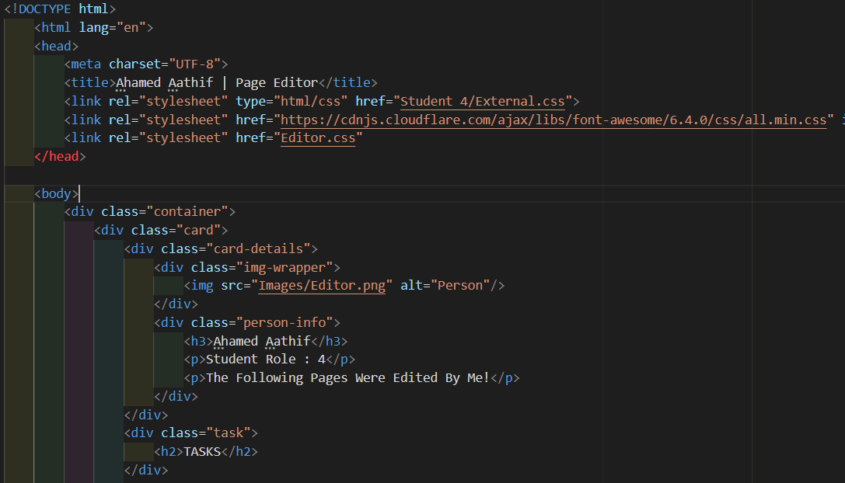

CSS Structure

The CSS styling, specified within an external stylesheet and utilizing the 'Poppins' font family, focuses on creating a clean, modern aesthetic that enhances readability and user engagement. The `.container` class centers the content, making it the focal point of the page. The `.card` class defines the presentation of the editor's profile, including background color, padding, and display properties to arrange the image and text informatively and attractively. The styling of `.task` elements with a distinct background color and font settings highlights the editor's responsibilities and achievements, encouraging user interaction. The responsive font sizes and colors ensure the content is accessible and appealing across different devices and viewing preferences.

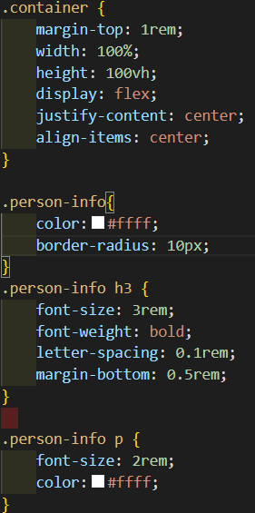
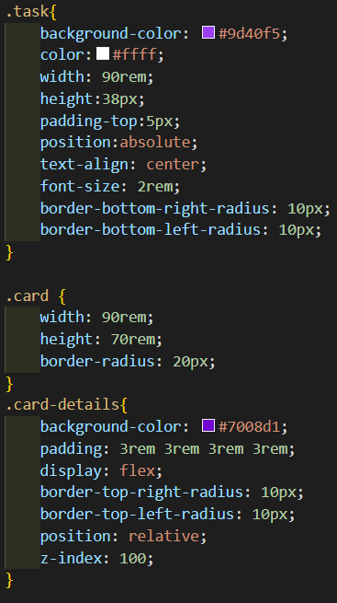

Visual and Interactive Elements

The use of an image wrapper and rounded borders adds a personal touch to the profile, making it visually appealing. The navigation through tasks using anchored links suggests an interactive element, allowing users to explore the editor's contributions in detail. Although not explicitly mentioned, the layout and styling pave the way for potential interactivity enhancements, such as modal pop-ups or dynamic content loading for each task, which could be achieved with JavaScript.

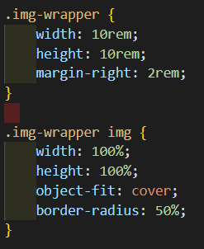

Conclusion

The page editor profile showcases effective web design principles, combining HTML structure and CSS styling to present content in an accessible, visually appealing manner. The design emphasizes the editor's contributions and roles within a project, providing clear navigation paths for further exploration of each task. This approach not only highlights the individual's skills and work but also enhances the overall user experience, reflecting a thoughtful and user-centric design philosophy.

5. Nav Bar
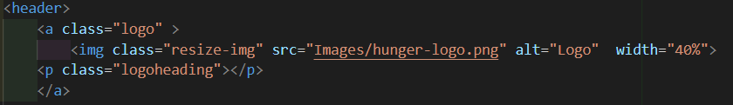

The above HTML code represents a logo for all pages. The "alt" attribute is indicating the alternative text logo and if user clicked the logo then it returns to Page Editor page.

<header>
<nav class="nav dark-nav">
<div class="container-header">
<div class="nav-heading">
<button class="toggle-nav" data-toggle="open-navbar1"><i class="fa fa-align-right"></i></button>
<a class="brand" href="#">
<img src="Images/hunger-logo.png" width="30%" alt="The Hunger Gap" srcset="">
</a>

</div>
<div class="menu" id="open-navbar1">
<ul class="list">
<li><a href="homepage.html">Main Page</a></li>
<li><a href="feedback.html">Feedback</a></li>
<li><a href="#">Shop</a></li>
<li><a class="nav-active" href="SiteMap.html">SiteMap</a></li>
<li><a href="Gallery2.html">Gallery</a></li>
<li><a href="#">Student Details</Details></a></li>
</ul>
</div>
</div>
</nav>
</header>

The <nav> element creates a navigation bar section on the webpage. Within the <nav> element, there is an <ul> element, representing an unordered list to organize the navigation items. ". The "href" attribute of each navigation link specifies the target page for the link. For example, “homepage.html” links to the “homepage.html” page and “Feedback.html” links to the “Feedback.html” page.

* header css starts */

.container-header:after,
.container-header:before {
content: "";
display: block;
clear: both;
}

/* Start navbar */
.nav {
background-color: #f8f8f8;
border-bottom: 1px solid #ececec;
min-height: 50px;
height: auto;
}

.nav .nav-heading {
float: left;
padding-left: 40px;
width: 40%;
height: 60px;
}

.nav .nav-heading .toggle-nav {
padding: 2px 10px;
border-radius: 5px;
border: none;
display: none;
background-color: transparent;
}

.nav .nav-heading>a {
text-decoration: none;
color: #000;
line-height: 60px;
font-weight: 400;
font-size: 19px;
}

/* Start menu */
list .nav .menu {
float: right;
}

.nav .menu:after {
content: "";
clear: both;
display: block;
}

.nav .list {
float: right;
margin: 0;
padding-right: 40px;
/* padding-top: 20px; */
/* height: 40px; */
}

.nav .list>li {
float: left;
list-style: none;
}

.nav .list>li>a {
color: #555;
text-decoration: none;
display: block;
line-height: 60px;
padding: 0 30px;
}

.nav .list>li>a:hover,
.nav .list>li.active>a {
color: #333
}

.brand img{
padding-top: 7px;
}
/* Start drodpwn menu */
.categories {
position: relative;
}

.show {
display: block
}

.menu .list li:active {
background-color: #0fc5d3;
}

/* Dark theme */
.dark-nav {
background-color: #0f4d88;
border: none;
}

.dark-nav .list>li>a {
color: #fff;
padding-bottom: 5px;
padding-top: 5px;
}

.dark-nav .list>li>a:hover,
.dark-nav .list>li.active>a {
color: #4fe6af
}

.dark-nav .nav-heading>a {
color: #EEE
}

.dark-nav .nav-heading .toggle-nav {
color: #EEE
}

.nav-active{
background-color: #0fc5d3;
}
/* End Dark theme */

/* Header css stoos */

The above CSS codes contains style of nav bar.

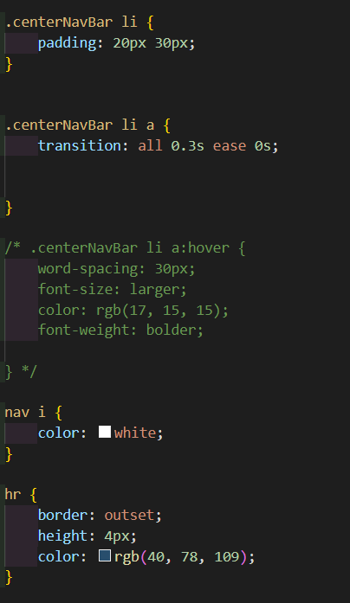

The above CSS codes contain background-color “black” this sets the background color of the active anchor link to "black," padding: 20px 30px of padding to the top and bottom. The padding creates space inside the link, making it visually more distinct and easier to click. color “white” This sets the text color of the active anchor link to white. The text inside the link will appear in white. Border to outset, This sets a border-radius to outset for the active anchor link.

3. Webpage Validation Statement
I validated the following pages using The W3C Markup Validation Service (https://validator.w3.org/).
- SiteMap
- Gallery
- Page with Additional Content
The validation tool verified that all three pages meet web standards. The pages were determined to be error-free.

4. Janet
In order to meet with Janet regulations, policies, and legal requirements, a website must follow guidelines on accessibility, privacy, security, copyright and intellectual property, Janet policies, and pertinent legal requirements. This includes following Janet policies and meeting applicable legal requirements, as well as following the Web Content Accessibility Guidelines and the General Data Protection Regulation. It also involves following Janet policies and following relevant legal requirements, as well as using secure protocols, respecting copyright and intellectual property laws, adhering to Janet policies, and adhering to relevant legal requirements. To guarantee compliance, a website should have a clear privacy policy, provide easy-to-use tools for users to control their data, monitor and update security measures, and seek legal advice. On this page, you will find information about accessibility, security, copyright and intellectual property, Janet policies, and applicable regulatory requirements. References Provide references to resources you have used.

Appendices

Appendix A: Code
Provide a full listing of your files, with well indented and commented code in the following format:

• Gallery Page HTML

<!DOCTYPE html>
<html lang="en" dir="ltr">
<head>
<meta charset="UTF-8">
<title>Gallery</title>
<link rel="stylesheet" href="https://cdnjs.cloudflare.com/ajax/libs/font-awesome/6.4.0/css/all.min.css" integrity="sha512-iecdLmaskl7CVkqkXNQ/ZH/XLlvWZOJyj7Yy7tcenmpD1ypASozpmT/E0iPtmFIB46ZmdtAc9eNBvH0H/ZpiBw==" crossorigin="anonymous" >
<link rel="stylesheet" href="gallery.css">

</head>
<body>
<header>
<nav class="nav dark-nav">
<div class="-container-header">
<div class="nav-heading">
<button class="toggle-nav" data-toggle="open-navbar1"><i class="fa fa-align-right"></i></button>
<a class="brand" href="#">
<img src="Images/hunger-logo.png" width="30%" alt="The Hunger Gap" srcset="">
</a>

</div>
<div class="menu" id="open-navbar1">
<ul class="list">
<li><a href="homepage.html">Main Page</a></li>
<li><a href="feedback.html">Feedback</a></li>
<li><a href="#">Shop</a></li>
<li><a href="SiteMap.html">SiteMap</a></li>
<li><a class="nav-active" href="Gallery2.html">Gallery</a></li>
<li><a href="#">Student Details</Details></a></li>
</ul>
</div>
</div>
</nav>
</header>

<section class="gallery-main">
<div class="gallery-container">
<div class="card">
<img class="gallery-image" src="Images/Meal-program.jpeg" alt="Meal-programs">
<div class="intro">
<h3> MEAL PROGRAMS </h3>
<p class="gallery-p">Offering free or subsidized meal programs, such as soup kitchens, community meals, and mobile food distribution services, to provide hot meals to those experiencing hunger.</p>
</div>
</div>
</div>
<div class="container">
<div class="card">
<img class="gallery-image" src="Images/School-feeding.jpeg" alt="School-feeding">
<div class="intro">
<h3> SCHOOL FEEDING PROGRAMS </h3>
<p class="gallery-p">Implementing school feeding programs that offer nutritious meals to students, particularly in low-income areas, ensuring that children have access to regular meals and can concentrate better in school.</p>
</div>
</div>
</div>
<div class="container">
<div class="card">
<img class="gallery-image" src="Images/Food-rescue.jpeg" alt="Food-rescue">
<div class="intro">
<h3> FOOD RESCUE PROGRAMS </h3>
<p class="gallery-p"> Collaborating with food retailers, restaurants, and farmers to rescue surplus food that would otherwise go to waste and redistribute it to those in need through food banks and other distribution channels.</p>
</div>
</div>
</div>
<div class="container">
<div class="card">
<img class="gallery-image" src="Images/Community-garden.jpeg" alt="Community-garden">
<div class="intro">
<h3> COMMUNITY GARDENS </h3>
<p class="gallery-p">Supporting community garden projects where residents can grow their own fruits and vegetables, fostering food self-sufficiency and promoting healthy eating habits. </p>
</div>
</div>
</div>

</section>
<hr>
<div class="footer-main">
<a href="Page-editor.html" class="ticker">Editor's page</a>
<a href="#" class="news-content">
This Page is designed by - Aathif
</a>
</div>
</body>
</html>

• Gallery Page CSS

@import url("https://fonts.googleapis.com/css2?family=Poppins&display=swap");
*{
margin: 0px;
padding: 0px;
font-family:Arial
}
.gallery-main{
display: flex;
justify-content: center;
height: 120vh;
background: whitesmoke;
align-items: center;
width: auto !important;
}
.card{
height: 450px ;
margin: 50px;
box-shadow: 5px 5px 20px black ;
overflow: hidden;
}
.gallery-image{
height: 500px;
width: 300px ;
border-radius: 3px;

}
.gallery-container{
display: flex
}
.intro{
height: 70px;
width: 300px;
padding: 6px;
box-sizing: border-box;
position: absolute;
border-bottom: 240px;
background: rgb(27, 27, 27, .5);
color: white;
}
h3{
margin: 10px;
font-size: 20px;
}
.gallery-p{
font-size: 15px;
margin: 20px;
visibility: hidden ;
opacity: 0;

}
span{
font-weight: bold;
}
.card:hover{
cursor: pointer;
}
.card:hover .intro{
height: 220px;
bottom: 240px;
background: black;
}
.card:hover p{
opacity: 1;
visibility: visible;
}
/* header css starts */

.container-header:after,
.container-header:before {
content: "";
display: block;
clear: both;
}

/* Start navbar */
.nav {
background-color: #f8f8f8;
border-bottom: 1px solid #ececec;
min-height: 50px;
height: auto;
}

.nav .nav-heading {
float: left;
padding-left: 40px;
width: 40%;
height: 60px;
}

.nav .nav-heading .toggle-nav {
padding: 2px 10px;
border-radius: 5px;
border: none;
display: none;
background-color: transparent;
}

.nav .nav-heading>a {
text-decoration: none;
color: #000;
line-height: 60px;
font-weight: 400;
font-size: 19px;
}

/* Start menu */
list .nav .menu {
float: right;
}

.nav .menu:after {
content: "";
clear: both;
display: block;
}

.nav .list {
float: right;
margin: 0;
padding-right: 40px;
/* padding-top: 20px; */
/* height: 40px; */
}

.nav .list>li {
float: left;
list-style: none;
}

.nav .list>li>a {
color: #555;
text-decoration: none;
display: block;
line-height: 60px;
padding: 0 30px;
}

.nav .list>li>a:hover,
.nav .list>li.active>a {
color: #333
}

.brand img{
padding-top: 7px;
}
/* Start drodpwn menu */
.categories {
position: relative;
}

.show {
display: block
}

.menu .list li:active {
background-color: #0fc5d3;
}

/* Dark theme */
.dark-nav {
background-color: #0f4d88;
border: none;
}

.dark-nav .list>li>a {
color: #fff;
padding-bottom: 5px;
padding-top: 5px;
}

.dark-nav .list>li>a:hover,
.dark-nav .list>li.active>a {
color: #4fe6af
}

.dark-nav .nav-heading>a {
color: #EEE
}

.dark-nav .nav-heading .toggle-nav {
color: #EEE
}

.nav-active{
background-color: #0fc5d3;
}
/* End Dark theme */

/* Header css stoos */

• SiteMap Page HTML

<!DOCTYPE html>
<html lang="en">
<head>
<meta charset="UTF-8">
<meta http-equiv="X-UA-Compatible" content="IE=edge">
<meta name="viewport" content="width=device-width, initial-scale=1.0">
<link rel="stylesheet" href="SiteMap.css">
<link rel="stylesheet" href="https://cdnjs.cloudflare.com/ajax/libs/font-awesome/6.4.0/css/all.min.css" integrity="sha512-iecdLmaskl7CVkqkXNQ/ZH/XLlvWZOJyj7Yy7tcenmpD1ypASozpmT/E0iPtmFIB46ZmdtAc9eNBvH0H/ZpiBw==" crossorigin="anonymous" >
<title> SiteMap </title>
</head>
<body>
<header>
<nav class="nav dark-nav">
<div class="container-header">
<div class="nav-heading">
<button class="toggle-nav" data-toggle="open-navbar1"><i class="fa fa-align-right"></i></button>
<a class="brand" href="#">
<img src="Images/hunger-logo.png" width="30%" alt="The Hunger Gap" srcset="">
</a>

</div>
<div class="menu" id="open-navbar1">
<ul class="list">
<li><a href="homepage.html">Main Page</a></li>
<li><a href="feedback.html">Feedback</a></li>
<li><a href="#">Shop</a></li>
<li><a class="nav-active" href="SiteMap.html">SiteMap</a></li>
<li><a href="Gallery2.html">Gallery</a></li>
<li><a href="#">Student Details</Details></a></li>
</ul>
</div>
</div>
</nav>
</header>
<div id="main-heading">
<h1> The Hunger Gap SiteMap </h1>
</div>
<div id="sitemap-svg">
<svg height="500" width="1500">
<a href="homepage.html">
<g id="home-box">
<rect x="690" y="125" rx="10" ry="10" width="150" height="60"/>
<text x="765" y="160">Home</text>
</g>
</a>

<a href="Gallery2.html">
<g id="gallery-box">
<rect x="125" y="285" rx="10" ry="10" width="150" height="60"/>
<text x="200" y="320">Gallery</text>
</g>
</a>

<a href="quiz.html">
<g id="quiz-box">
<rect x="407.5" y="285" rx="10" ry="10" width="150" height="60"/>
<text x="482.5" y="320">Quiz</text>
</g>
</a>

<a href="shop.html">
<g id="shop-box">
<rect x="690" y="285" rx="10" ry="10" width="150" height="60"/>
<text x="765" y="320">Store</text>
</g>
</a>

<a href="Student_Details.html">
<g id="about-us-box">
<rect x="966" y="285" rx="10" ry="10" width="150" height="60"/>
<text x="1041" y="320">About Us</text>
</g>
</a>

<a href="feedback.html">
<g id="feedback-box">
<rect x="1250" y="285" rx="10" ry="10" width="150" height="60"/>
<text x="1325" y="320">Feedback</text>
</g>
</a>

<g>
<line stroke="#7008d1" stroke-width="4" x1="765" y1="185" x2="765" y2="235"/>
<line stroke="#7008d1" stroke-width="4" x1="200" y1="235" x2="1325" y2="235"/>
<line stroke="#7008d1" stroke-width="4" x1="201.5" y1="235" x2="201.5" y2="285"/>
<line stroke="#7008d1" stroke-width="4" x1="482.5" y1="235" x2="482.5" y2="285"/>
<line stroke="#7008d1" stroke-width="4" x1="765" y1="235" x2="765" y2="285"/>
<line stroke="#7008d1" stroke-width="4" x1="1041" y1="235" x2="1041" y2="285"/>
<line stroke="#7008d1" stroke-width="4" x1="1323.5" y1="235" x2="1323.5" y2="285"/>
</g>
</svg>
</div>
<hr>

<div class="footer-main">
<a href="Page-editor.html" class="ticker">Editor's page</a>
<a href="#" class="news-content">
This Page is designed by - Aathif
</a>
</div>
</body>
</html>

• SiteMap Page CSS

@import url("https://fonts.googleapis.com/css2?family=Poppins&display=swap");

body {
background-size: cover;
background-attachment:fixed;
}

#main-heading {

margin-top: 150px;
margin-left: 600px;
font-family: 'Poppins', sans-serif;
}

#main-heading h1{
color: black;
}

#sitemap-svg line{
stroke-width: 2;
stroke: #161469;
}

#sitemap-svg rect{
fill: #000;
fill-opacity: 0.6;
stroke-width: 2;
stroke: #fff;
transition: fill 0.15s, stroke 0.15s;
}

#sitemap-svg text{
fill: #fff;
font-size: 18px;
font-family: 'Poppins', sans-serif;
text-anchor: middle;
transition: font-size 0.15s;
}

#sitemap-svg g:hover rect {
fill: #0c4e8b;
fill-opacity: 1;
stroke: #310371;
cursor: pointer;
}

#sitemap-svg g:hover text {
font-size: 21px;
cursor: pointer;
}

#sitemap-svg g:active rect {
fill-opacity: 0.8;
stroke-opacity: 0.1;
}

#sitemap-svg g:active text {
fill: #0c4e8b;
fill-opacity: 0.6;
}

#group{
text-align: center;
}

/* header css starts */

.container-header:after,
.container-header:before {
content: "";
display: block;
clear: both;
}

/* Start navbar */
.nav {
background-color: #f8f8f8;
border-bottom: 1px solid #ececec;
min-height: 50px;
height: auto;
}

.nav .nav-heading {
float: left;
padding-left: 40px;
width: 40%;
height: 60px;
}

.nav .nav-heading .toggle-nav {
padding: 2px 10px;
border-radius: 5px;
border: none;
display: none;
background-color: transparent;
}

.nav .nav-heading>a {
text-decoration: none;
color: #000;
line-height: 60px;
font-weight: 400;
font-size: 19px;
}

/* Start menu */
list .nav .menu {
float: right;
}

.nav .menu:after {
content: "";
clear: both;
display: block;
}

.nav .list {
float: right;
margin: 0;
padding-right: 40px;
/* padding-top: 20px; */
/* height: 40px; */
}

.nav .list>li {
float: left;
list-style: none;
}

.nav .list>li>a {
color: #555;
text-decoration: none;
display: block;
line-height: 60px;
padding: 0 30px;
}

.nav .list>li>a:hover,
.nav .list>li.active>a {
color: #333
}

.brand img{
padding-top: 7px;
}
/* Start drodpwn menu */
.categories {
position: relative;
}

.show {
display: block
}

.menu .list li:active {
background-color: #0fc5d3;
}

/* Dark theme */
.dark-nav {
background-color: #0f4d88;
border: none;
}

.dark-nav .list>li>a {
color: #fff;
padding-bottom: 5px;
padding-top: 5px;
}

.dark-nav .list>li>a:hover,
.dark-nav .list>li.active>a {
color: #4fe6af
}

.dark-nav .nav-heading>a {
color: #EEE
}

.dark-nav .nav-heading .toggle-nav {
color: #EEE
}

.nav-active{
background-color: #0fc5d3;
}
/* End Dark theme */

/* Header css stoos */

• Content Page HTML
<!DOCTYPE html>
<html lang="en">

<head>
<meta charset="UTF-8">
<meta name="viewport" content="width=device-width, initial-scale=1.0">
<meta http-equiv="X-UA-Compatible" content="ie=edge">
<title> Content Page | Aathif </title>
<link rel="stylesheet" href="Content.css">
</head>

<body>
<header>
<nav class="nav dark-nav">
<div class="container-header">
<div class="nav-heading">
<button class="toggle-nav" data-toggle="open-navbar1"><i class="fa fa-align-right"></i></button>
<a class="brand" href="#">
<img src="Images/hunger-logo.png" width="30%" alt="The Hunger Gap" srcset="">
</a>

</div>
<div class="menu" id="open-navbar1">
<ul class="list">
<li><a href="homepage.html">Main Page</a></li>
<li><a href="feedback.html">Feedback</a></li>
<li><a href="#">Shop</a></li>
<li><a href="SiteMap.html">SiteMap</a></li>
<li><a href="Gallery2.html">Gallery</a></li>
<li><a href="#">Student Details</Details></a></li>
</ul>
</div>
</div>
</nav>
</header>

<div class="content-primary">
<div class="content-about">
<div class="content-text content-text-primary" style="text-align: center;">
<h2>Zero Hunger</h2>

<h4>Sustainable <span class="cntent-span">Solutions</span></h4>
<p>Highlighting sustainable solutions and interventions aimed at addressing hunger, including agricultural innovation, food distribution systems, poverty alleviation programs, and policy reforms.</p>
<div class="content-data">
<a href="#topic-1" class="content-hire">Agricultural Innovation</a>
<a href="#topic-2" class="content-hire">Food Distribution Systems</a>
<a href="#topic-3" class="content-hire">Poverty Alleviation Programs</a>
<a href="#topic-4" class="content-hire">Policy Reforms</a>
</div>
</div>
</div>
</div>

<div class="content-main-1" id="topic-1">
<div class="content-about">
<img src="Images/Agricultural-Innovations.jpg" alt="Agricultural-Innovations" class="content-pic">
<div class="content-text">
<h3><span class="cntent-span">Agricultural Innovation</span></h3>
<p> Investing in agricultural innovation is crucial for increasing food production and resilience to climate change.
This includes promoting sustainable farming practices such as agroecology, precision agriculture, and drought-resistant crop varieties.
Additionally, supporting small-scale farmers with access to technology, training, and resources can enhance productivity and livelihoods.</p>

</div>
</div>
</div>

<div class="content-main-2" id="topic-2">
<div class="content-about">

<div class="content-text">
<h3><span class="cntent-span">Food Distribution Systems</span></h3>
<p> Improving food distribution systems is essential for ensuring equitable access to nutritious food.
This involves enhancing infrastructure for storage, transportation, and market access, particularly in rural and remote areas.
Utilizing technology such as mobile applications for supply chain management and establishing community-based food cooperatives can streamline distribution and reduce food waste.</p>

</div>
<img src="Images/Food-distribution-system.jpg" alt="Food-distribution-system" class="content-pic">
</div>
</div>

<div class="content-main-1" id="topic-3">
<div class="content-about">
<img src="Images/Poverty-alleviation.jpg" alt="Poverty-alleviation" class="content-pic">
<div class="content-text">
<h3><span class="cntent-span">Poverty Alleviation Programs</span></h3>
<p> Addressing poverty is fundamental to tackling hunger, as poverty often serves as a root cause of food insecurity.
Implementing poverty alleviation programs such as cash transfers, microfinance initiatives, and vocational training can empower vulnerable communities to improve their livelihoods and access nutritious food.</p>

</div>
</div>
</div>

<div class="content-main-2" id="topic-4">
<div class="content-about">

<div class="content-text">
<h3><span class="cntent-span">Policy Reforms</span></h3>
<p>Enacting policy reforms at national and international levels is crucial for creating an enabling environment for food security.
This includes policies that prioritize investment in agriculture, regulate land rights, promote sustainable resource management, and support social safety nets for the most vulnerable populations.
Furthermore, advocating for policies that address inequalities in access to resources, gender disparities, and conflict resolution can contribute to long-term solutions to hunger.</p>

</div>
<img src="Images/Policy-reform.jpg" alt="Policy-reform" class="content-pic">
</div>
</div>
<div class="footer-main">
<a href="Page-editor.html" class="ticker">Editor's page</a>
<a href="#" class="news-content">
This Page is designed by - Aathif
</a>
</div>
</body>
</html>

• Content Page CSS

@import url('https://fonts.googleapis.com/css2?family=Poppins:wght@200;300;400;500&display=swap');

* {
margin: 0;
padding: 0;
box-sizing: border-box;
font-family: 'Poppins', sans-serif;
}

.content-main-1,
.content-main-2,
.content-primary {
height: auto;
width: 100%;
padding-top: 50px;
padding-bottom: 50px;
}

.content-primary {
background: #ccf2cd;
}

.content-main-1 {

background: #ddd;
}

.content-main-2 {
background-color: #fff;
}

.content-pic {
height: auto;
width: 302px;
}

.content-about {
width: 1130px;
max-width: 85%;
margin: 0 auto;
display: flex;
align-items: center;
justify-content: space-around;
}

.content-text {
width: 540px;
}

.content-text-primary {
width: 840px;
}

.content-text h2 {
font-size: 30px;
font-weight: 600;
margin-bottom: 10px;

}

.content-text h5 {
font-size: 23px;
font-weight: 500;
margin-bottom: 20px;
font-weight: 800;
}

.cntent-span {
color: #0c4e8b;
}

.content-text p {
font-size: 18px;
line-height: 25px;
letter-spacing: 1px;
}

.content-data {
margin-top: 30px;
display: flex;
flex-direction: column;
align-items: center;
}

.content-hire {
margin: 5px;
font-size: 18px;
background: #0c4e8b;
color: #fff;
text-decoration: none;
border: none;
padding: 8px 25px;
border-radius: 6px;
transition: 0.5s;
}

.content-hire:hover {
background: #000;
border: 1px solid #0c4e8b;
}

.content-space {
margin-top: 200px;
}
.content-hire{
width:500px;
}
/* header css starts */

.container-header:after,
.container-header:before {
content: "";
display: block;
clear: both;
}

/* Start navbar */
.nav {
background-color: #f8f8f8;
border-bottom: 1px solid #ececec;
min-height: 50px;
height: auto;
}

.nav .nav-heading {
float: left;
padding-left: 40px;
width: 40%;
height: 60px;
}

.nav .nav-heading .toggle-nav {
padding: 2px 10px;
border-radius: 5px;
border: none;
display: none;
background-color: transparent;
}

.nav .nav-heading>a {
text-decoration: none;
color: #000;
line-height: 60px;
font-weight: 400;
font-size: 19px;
}

/* Start menu */
list .nav .menu {
float: right;
}

.nav .menu:after {
content: "";
clear: both;
display: block;
}

.nav .list {
float: right;
margin: 0;
padding-right: 40px;
/* padding-top: 20px; */
/* height: 40px; */
}

.nav .list>li {
float: left;
list-style: none;
}

.nav .list>li>a {
color: #555;
text-decoration: none;
display: block;
line-height: 60px;
padding: 0 30px;
}

.nav .list>li>a:hover,
.nav .list>li.active>a {
color: #333
}

.brand img{
padding-top: 7px;
}
/* Start drodpwn menu */
.categories {
position: relative;
}

.show {
display: block
}

• Page Editor Page HTML
<!DOCTYPE html>
<html lang="en">
<head>
<meta charset="UTF-8">
<title>Ahamed Aathif | Page Editor</title>
<link rel="stylesheet" type="html/css" href="Student 4/External.css">
<link rel="stylesheet" href="https://cdnjs.cloudflare.com/ajax/libs/font-awesome/6.4.0/css/all.min.css" integrity="sha512-iecdLmaskl7CVkqkXNQ/ZH/XLlvWZOJyj7Yy7tcenmpD1ypASozpmT/E0iPtmFIB46ZmdtAc9eNBvH0H/ZpiBw==" crossorigin="anonymous" >>
<link rel="stylesheet" href="Editor.css">
</head>

<body>
<div class="container">
<div class="card">
<div class="card-details">
<div class="img-wrapper">
<img src="Images/Editor.png" alt="Person"/>
</div>
<div class="person-info">
<h3>Ahamed Aathif</h3>
<p>Student Role : 4</p>
<p>The Following Pages Were Edited By Me!</p>
</div>
</div>
<div class="task">
<h2>TASKS</h2>
</div>
<div class="task-one">
<h3><a href="SiteMap.html">Site Map</a></h3>
<p>
Creating a site map similar to what you described involves conceptualizing the structure of a website in a way that effectively displays its hierarchy and the relationships between different pages.
A site map like this is essential for both users, to help them navigate the site, and for web developers or designers, to plan and organize the site's content.</p>
</div>
<div class="task-two">
<h3><a href="Gallery2.html">Gallery</a></h3>
<p>A thumbnail page, also known as a gallery, is a webpage that displays a collection of images or videos in a grid-like format.
The images or videos are usually displayed as smaller thumbnail versions, which can be clicked or tapped to view a larger version.</p>
</div>
<div class="task-three">
<h3><a href="ContentPage.html">Content Page</a></h3>
<p>Creating an effective content page—a page specifically designed to present articles, blog posts, product descriptions, tutorials, or any other form of content—is crucial for engaging visitors and providing valuable information.</p>
</div>
</div>
</div>
</body>
</html>

• Page Editor Page CSS

@import url("https://fonts.googleapis.com/css2?family=Poppins:wght@100;300;400;500;600&display=swap");
* {
margin: 0;
padding: 0;
font-family: 'Poppins', sans-serif;
}

html {
font-size: 55%;
}

body{
background-color: #141414;
}

.container {
margin-top: 1rem;
width: 100%;
height: 100vh;
display: flex;
justify-content: center;
align-items: center;
}

.person-info{
color:#ffff;
border-radius: 10px;
}
.person-info h3 {
font-size: 3rem;
font-weight: bold;
letter-spacing: 0.1rem;
margin-bottom: 0.5rem;
}

.person-info p {
font-size: 2rem;
color:#ffff;
}

.img-wrapper {
width: 10rem;
height: 10rem;
margin-right: 2rem;
}

.img-wrapper img {
width: 100%;
height: 100%;
object-fit: cover;
border-radius: 50%;
}

.task{
background-color: #9d40f5;
color:#ffff;
width: 90rem;
height:38px;
padding-top:5px;
position:absolute;
text-align: center;
font-size: 2rem;
border-bottom-right-radius: 10px;
border-bottom-left-radius: 10px;
}

.card {
width: 90rem;
height: 70rem;
border-radius: 20px;
}
.card-details{
background-color: #7008d1;
padding: 3rem 3rem 3rem 3rem;
display: flex;
border-top-right-radius: 10px;
border-top-left-radius: 10px;
position: relative;
z-index: 100;
}

.task-one,.task-two,.task-three{
height:90px;
left:0;
bottom: 0;
top: 10%;
padding: 12px;
margin-top:15px;
margin-bottom: 15px;
position: relative;
border-radius: 10px;
justify-content: left;
align-items: last baseline;
color: rgb(248, 248, 248);
font-size: larger;
}

.task-one h3{
color: #e6e6e6;
font-size: 2.6rem;
text-align: center;
text-decoration: #e6e6e6;
}

.task-two h3{
font-size: 2.6rem;
text-align: center;

}

.task-three h3{
font-size: 2.6rem;
text-align: center;
}

.task-one,.task-two,.task-three, p {
font-size: 1.6rem;
color: rgb(255, 255, 255);
letter-spacing: 0.0.1rem;
}

a {
color: #fff;
text-decoration: none;
background-color: #333;
display: inline-block;
width: 750px;
padding: 5px 10px ;
border-radius: 5px;
transition: background-color 0.3s ease;
}

a:hover {
color: #9d40f5;
text-decoration: #9d40f5;
}

Appendix B: Screenshots
Provide a screenshot of all your web pages, in the following format:

• Gallery Page
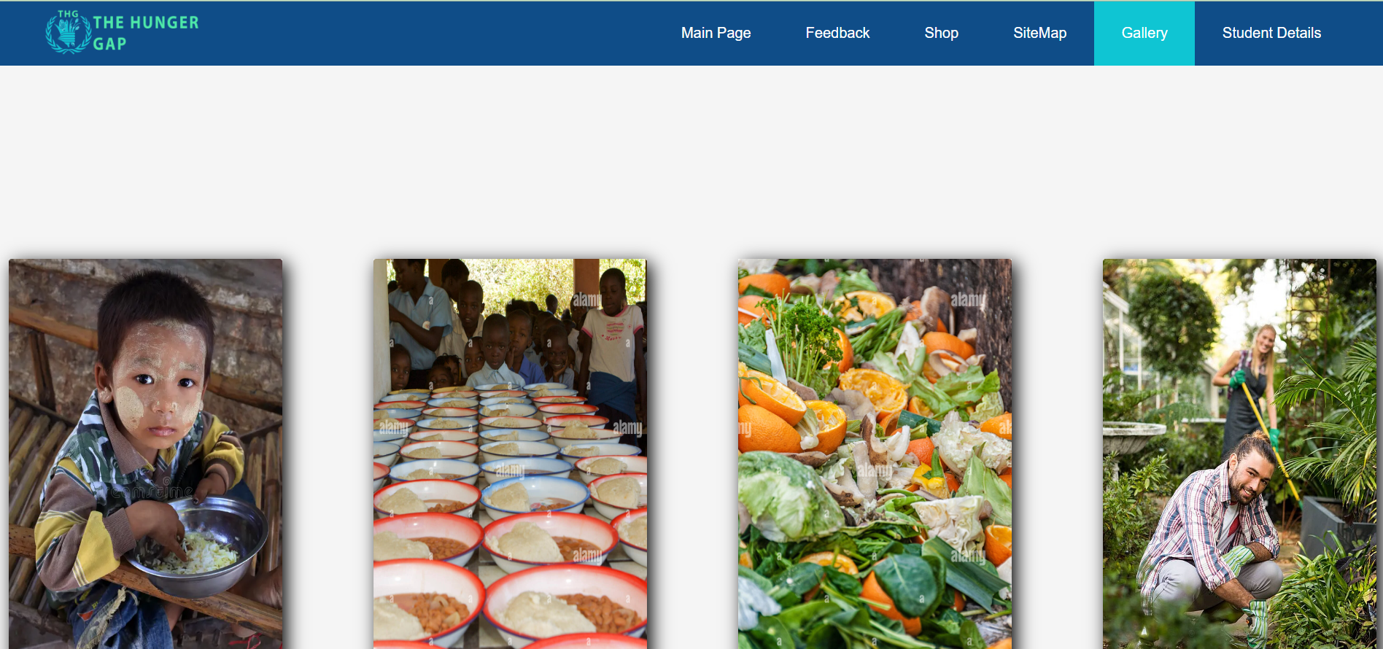

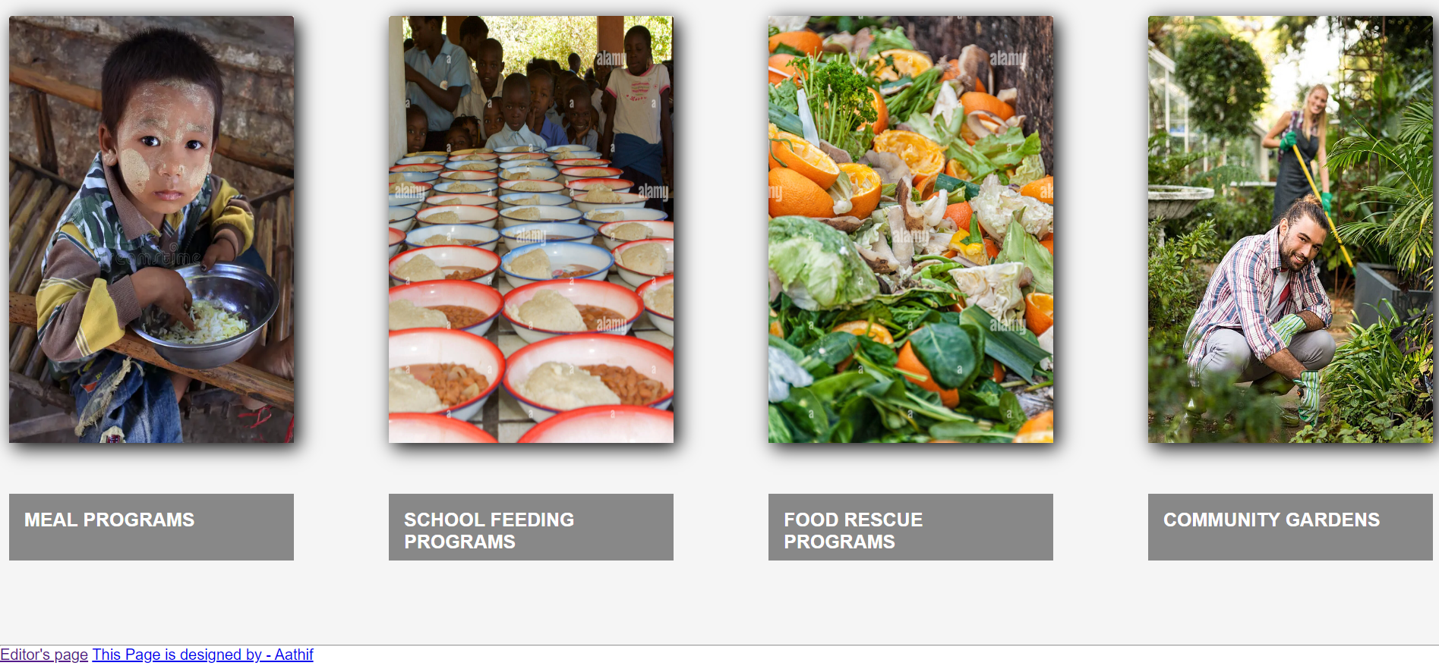

• SiteMap Page
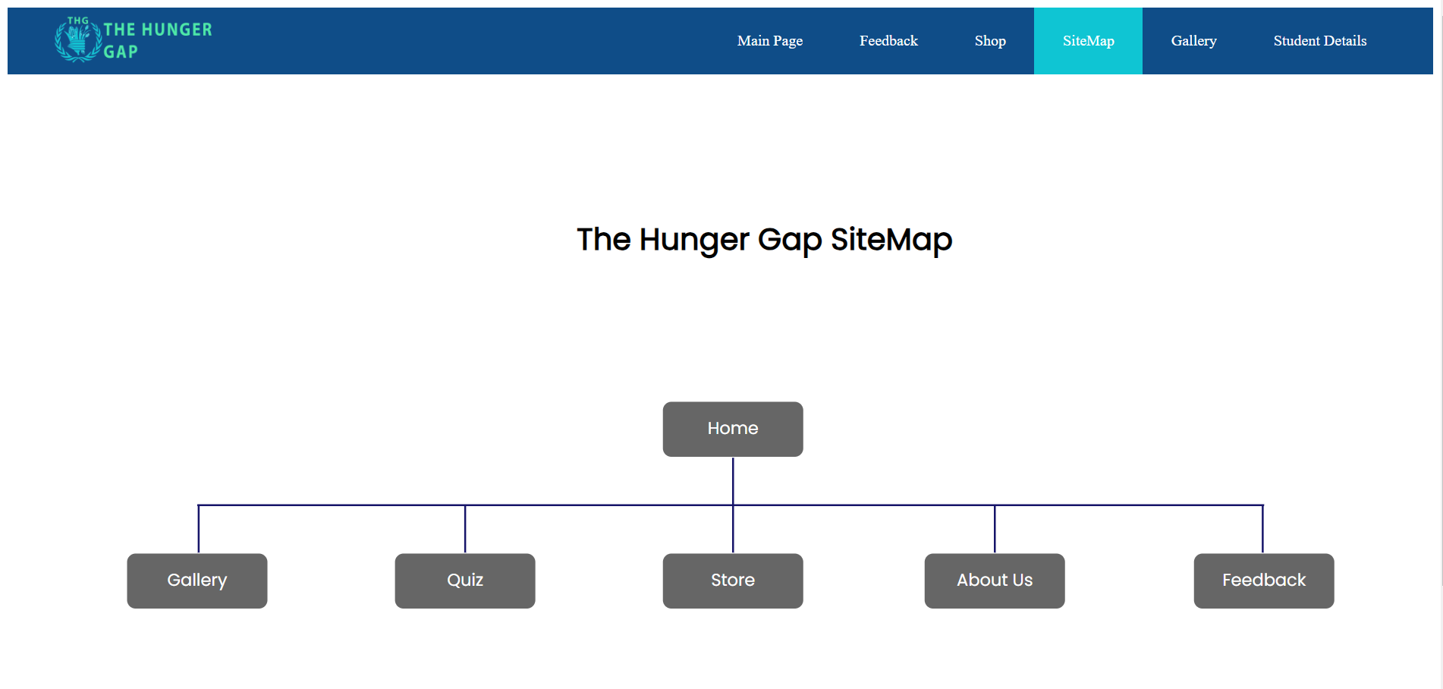

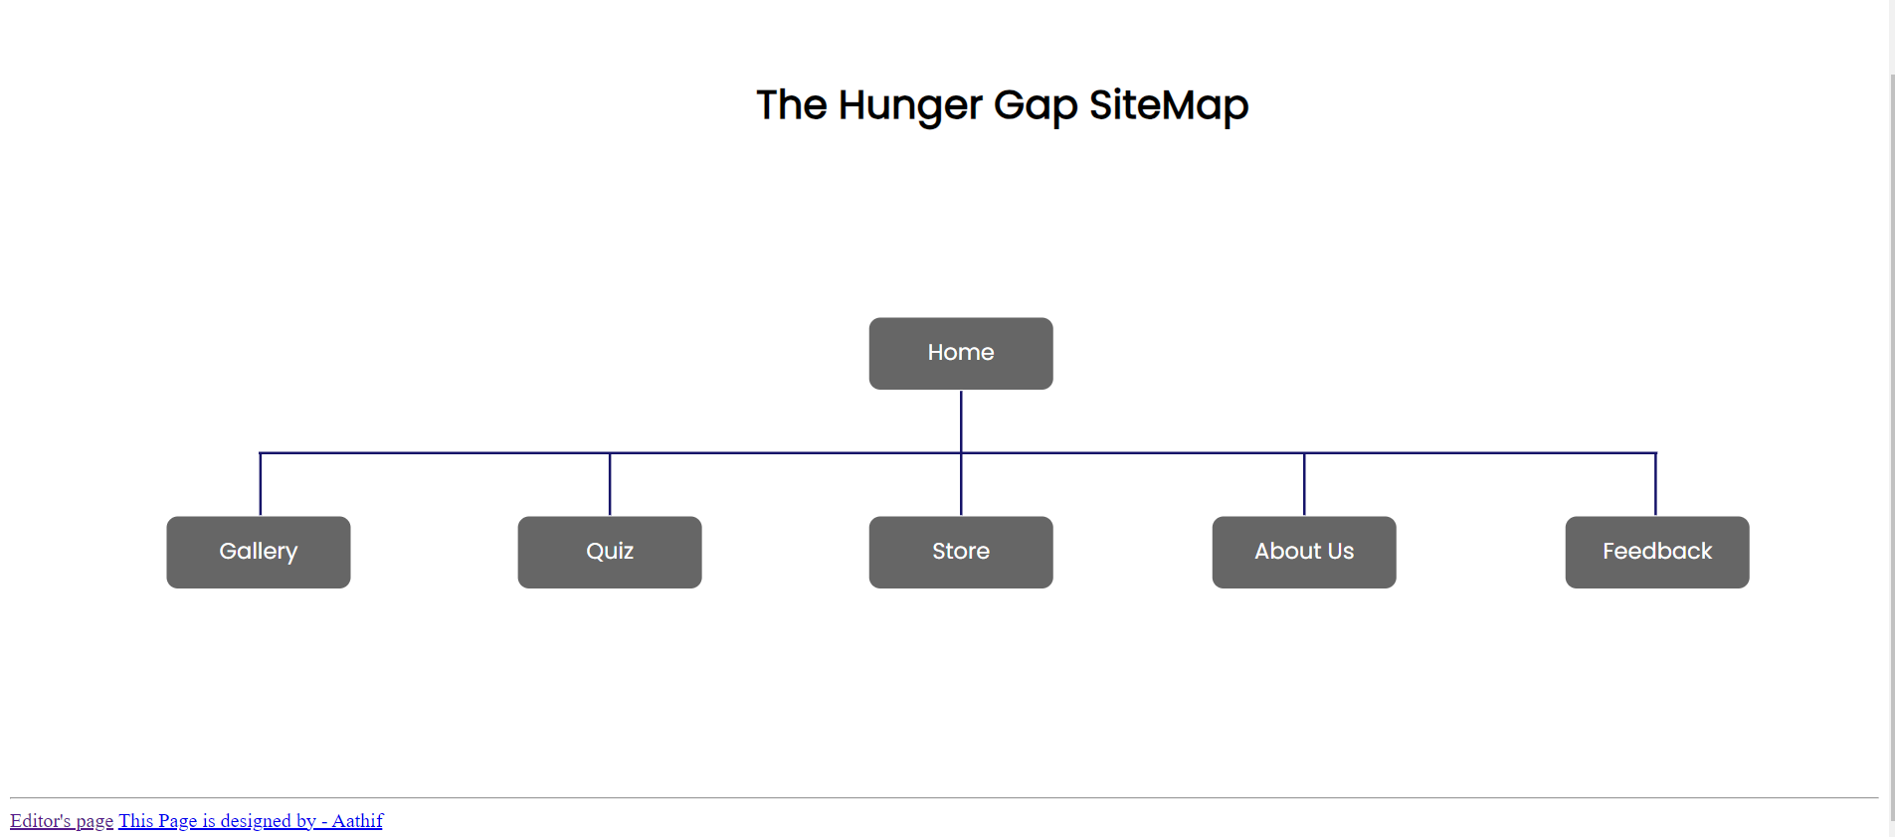

• Content Page

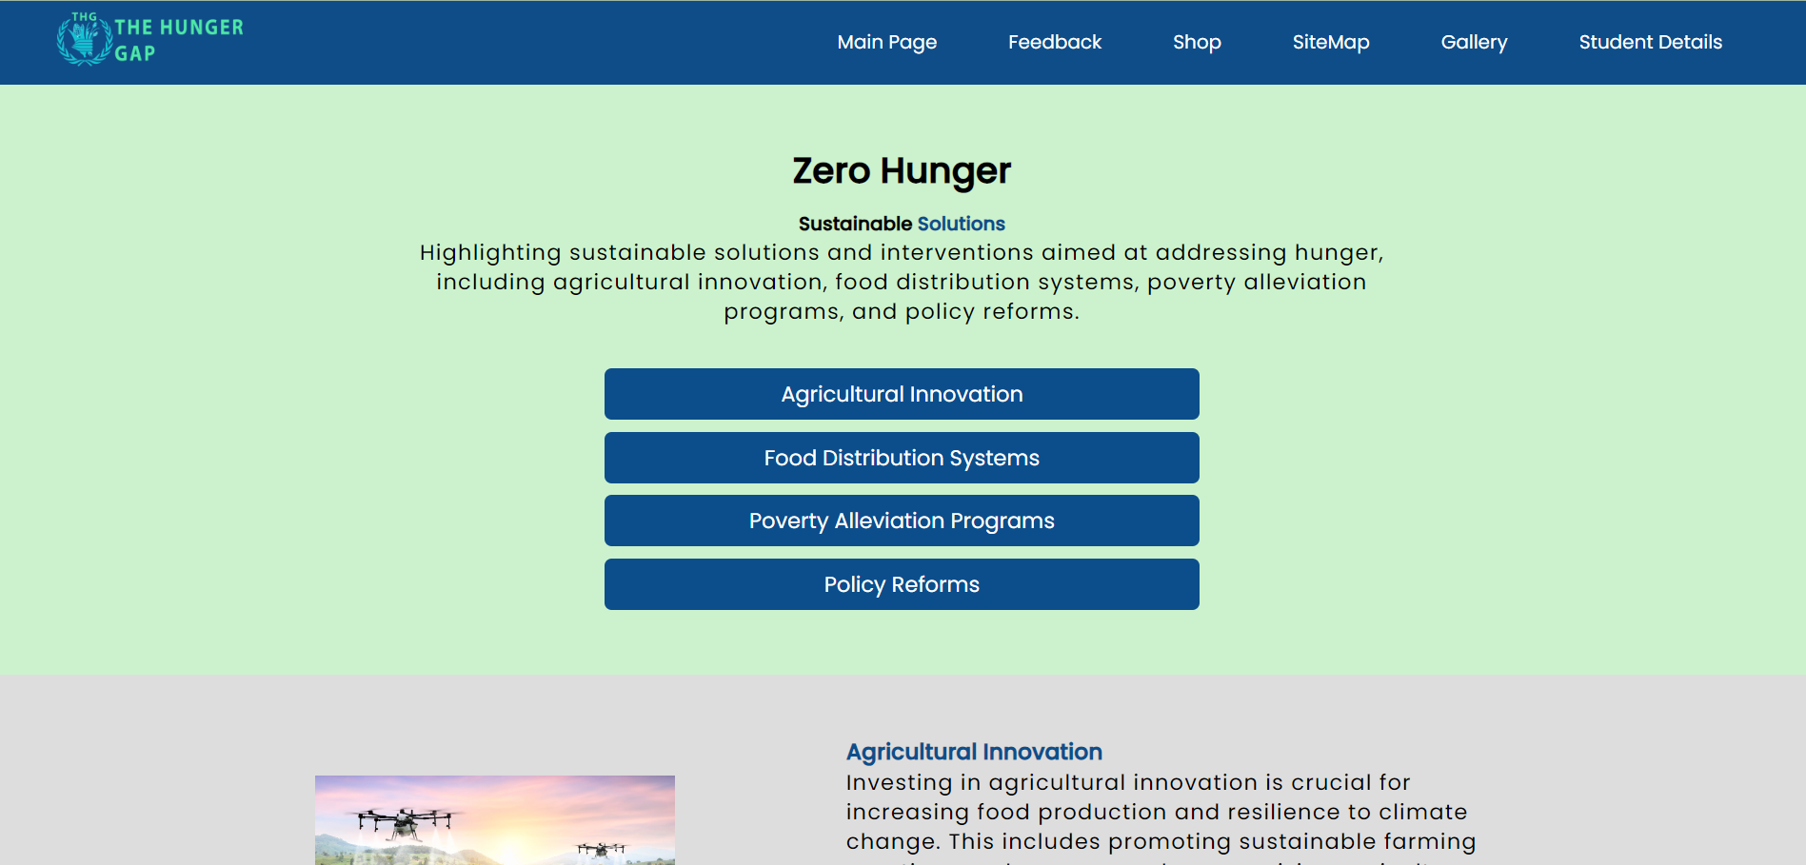

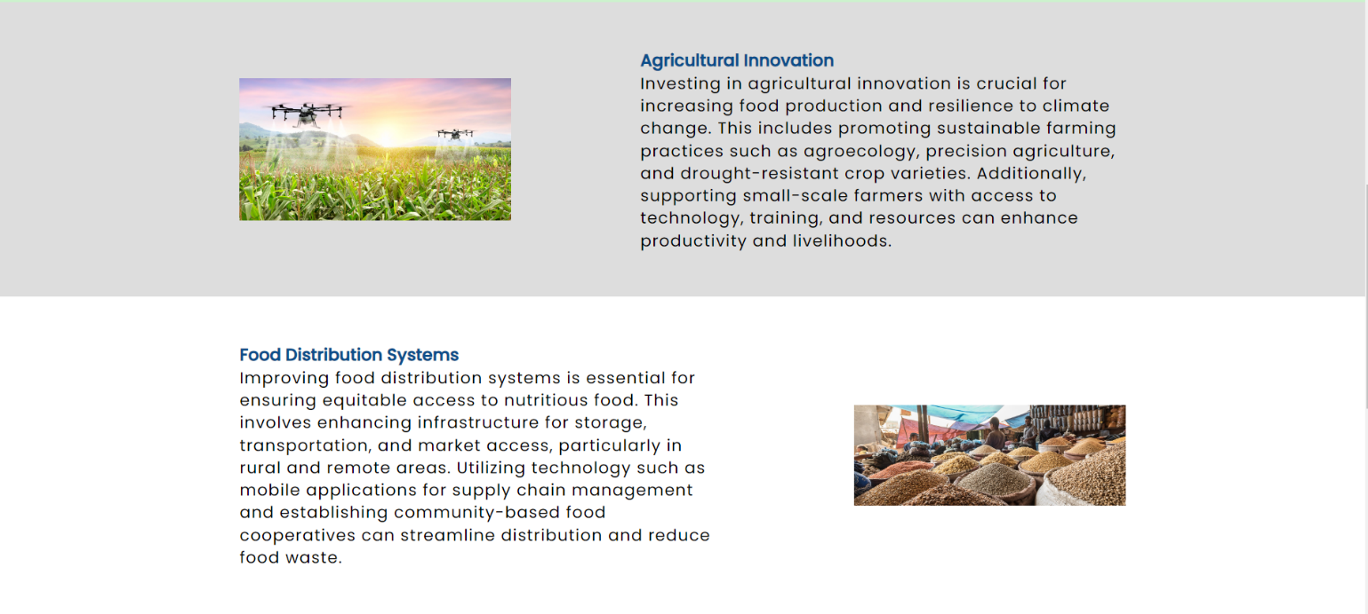

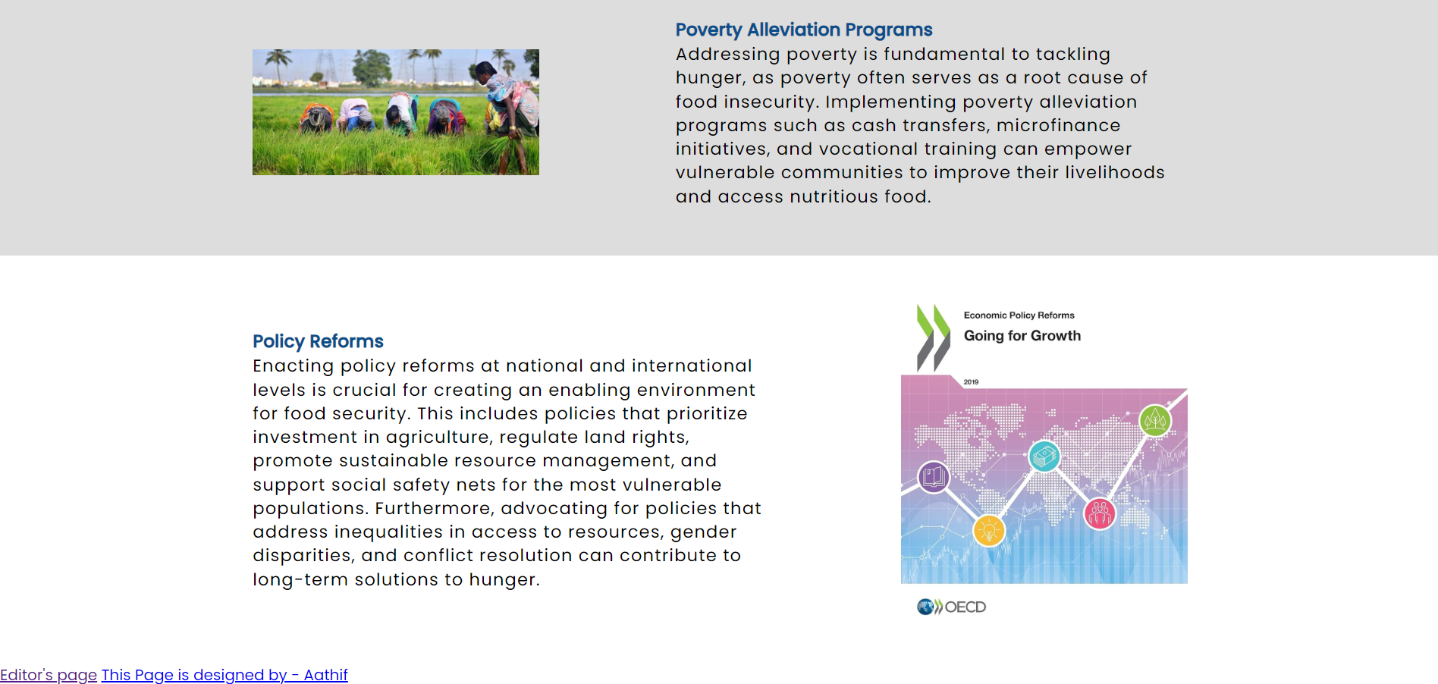

• Page Editor

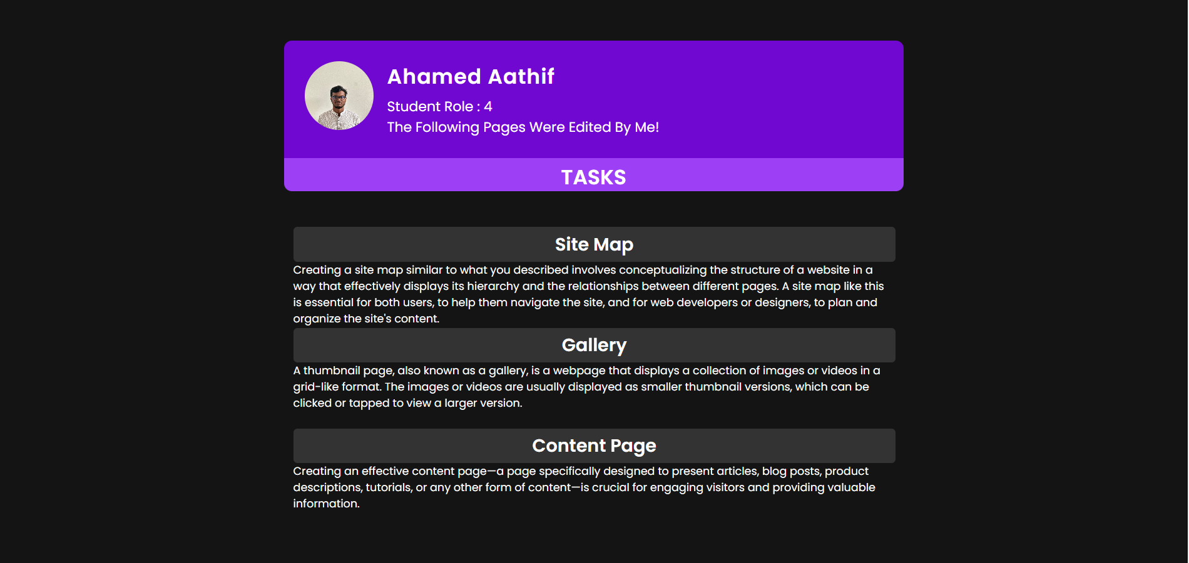

Appendix C: Screenshots - Webpage Validation Evidence

• SiteMap Page
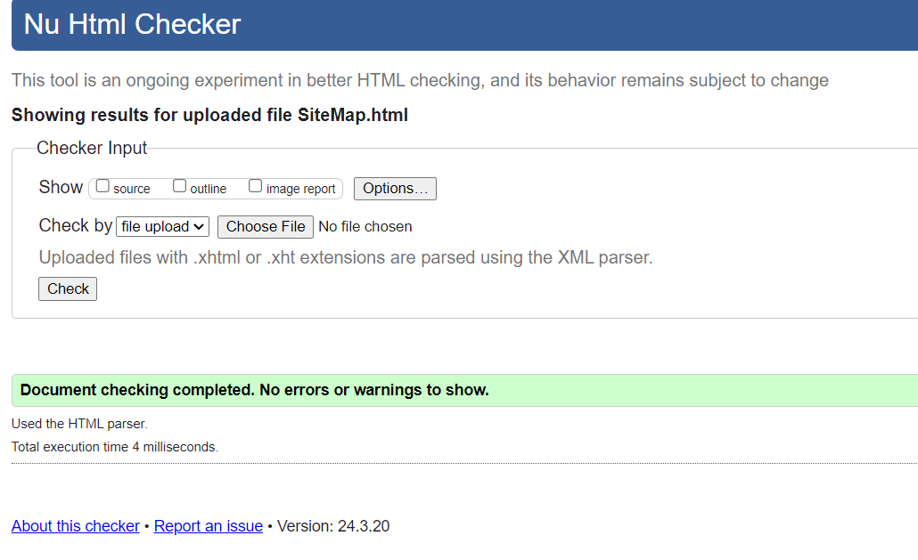

• Gallery Page
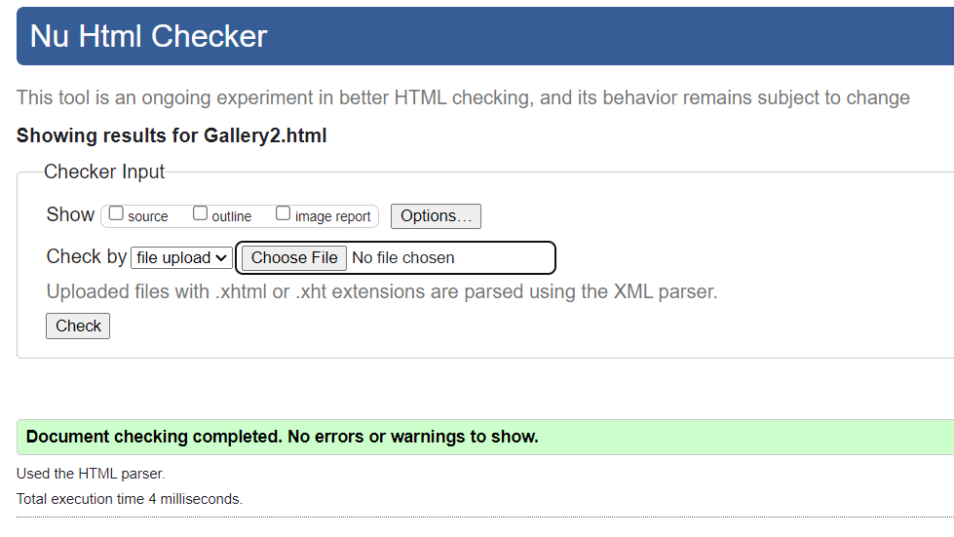

• Content Page
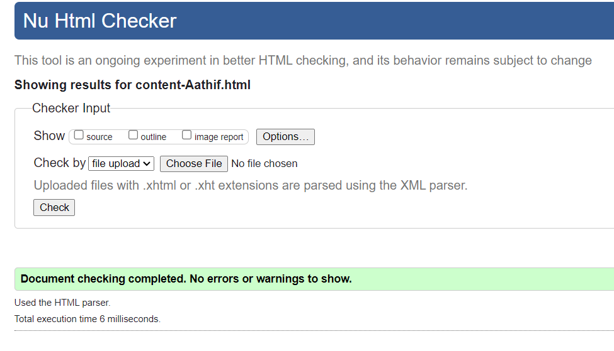

Appendix D: Individual Statement

Student Name: | Ahamed Aathif | Student Id: | W2053156 / 20222350
State what tasks you carried out in the project.
- Created the sitemap
- Created the gallery
- Set up navigation bars to link pages.
- Added external CSS to the header and footer of the website.
- All the codes are validated.

State what you enjoyed and did not enjoy about teamwork.
• I liked the part where the crew talked about every problem and found solutions.

State what you learnt about teamwork.
• I gained knowledge from this course work in the areas of teamwork, resource management, and time management.

State what skills you gained/learnt from undertaking the project.
- Respecting the thoughts, opinions, and viewpoints of other members.
- Talents in communication.
- Additional understanding of JavaScript and CSS.
- Learned the right way to make a website.

State any strengths about yourself that emerged whilst undertaking the project.
- Communication skills.
- Respecting other people's viewpoints.
- Timeliness and good planning.

State any weaknesses about yourself that emerged whilst undertaking the project.
• I made some small mistakes when making this project.

State how you would do things better if you were to undertake the project again.
• Should improve my knowledge of HTML, CSS, and JavaScript to create a more
responsive website.

Additional general or project specific comments:
• I realized the importance of self-studying and the existence of search engines.

Appendix E: Task Completion Checklist
Complete the table to indicate if any of your tasks were not completed or partially completed.

Student 2 Tasks | Completed |  |  | Student Comments
Student 2 Tasks | Yes | No | Partially
3.1.3 - Gallery | √ |  |  | Task completed
3.1.7 - SiteMap | 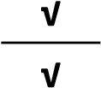 |  |  | Task completed
3.1.9 – Content page |  |  |  | Task completed
3.1.10 – Page Editor | √ |  |  | Task completed
3.1.11 – Additional JavaScript |  |  | √ | Task completed
3.1.12 – General coursework requirements | √ |  |  | Task completed
3.1.14 – Contribution to group meetings | √ |  |  | Task completed
4 – Uploaded to WebServer |  | √

